1 pt. **Project Site Title**: OMIS Class Catalog

1 pt. **Client**: OMIS Dept.

2 pts. **Goal**: Our goal is to allow users to dive deeper into the classes available. By having an interactive website that breaks down the OM&IS classes by emphasis we can help students target specific goals of theirs. We also plan on letting students filter by professors so they can see what classes are taunt be a specific professor they are interested in.

2pts. **Audience** 1. Our customer base is students who want to learn more about classes and professors teaching them.

2 pts. 1. **Describe your project road map:** We are currently doing the layout of our site as we want to be clear what are purpose is before getting too far ahead. 2. **How far along is the idea development:** We have a solid foundation of our goals and expectations but have not started actually writing up the website.

2 pts. **Site Map**: 1. Home 2. Operations Management 3.Information Systems 4. Data Analytics

1 pt. **Inspiration Site**: Screenshot of 1 or 2 websites to use as design inspiration - Templated.co for example

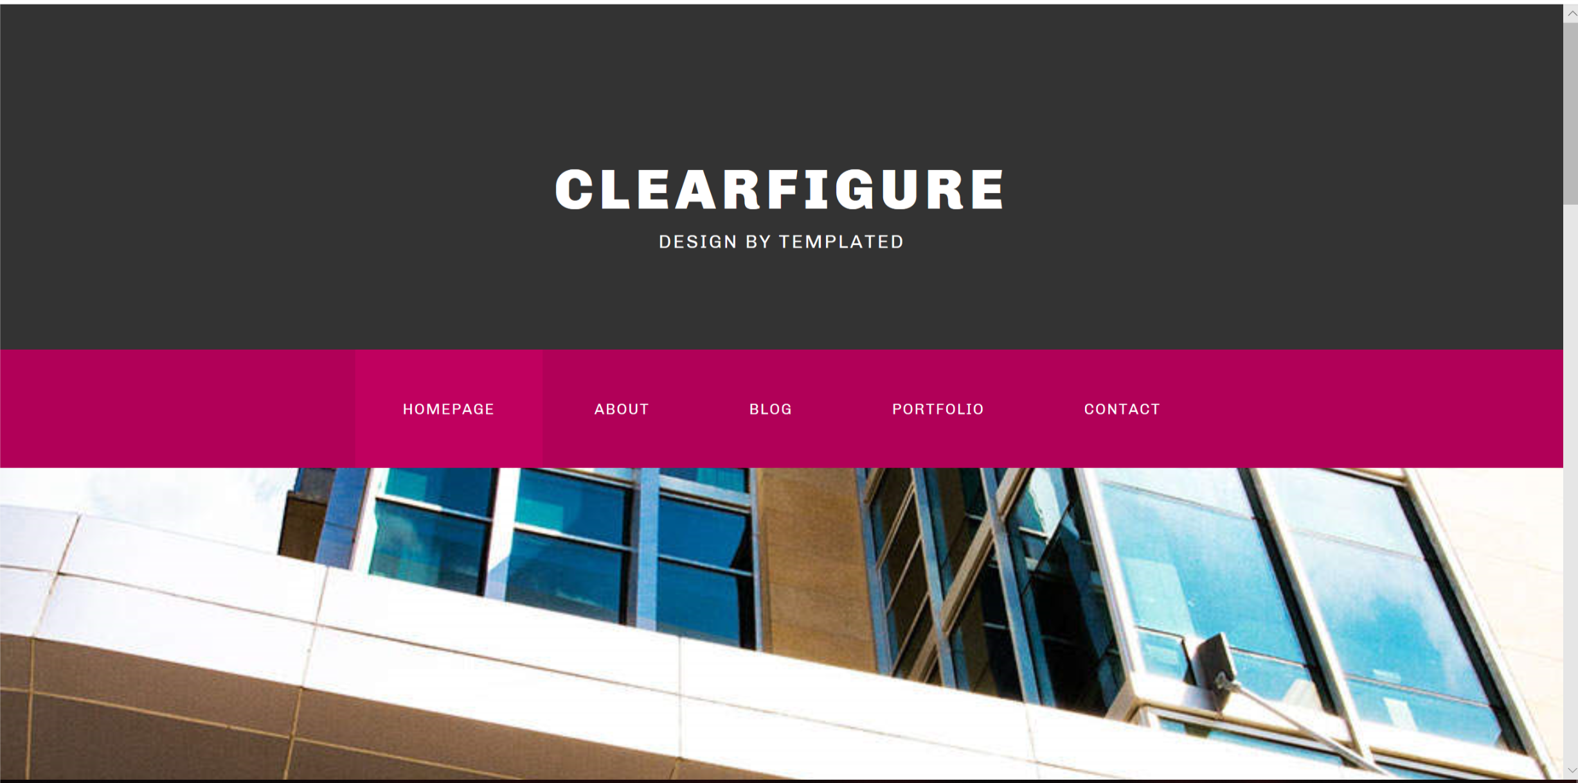

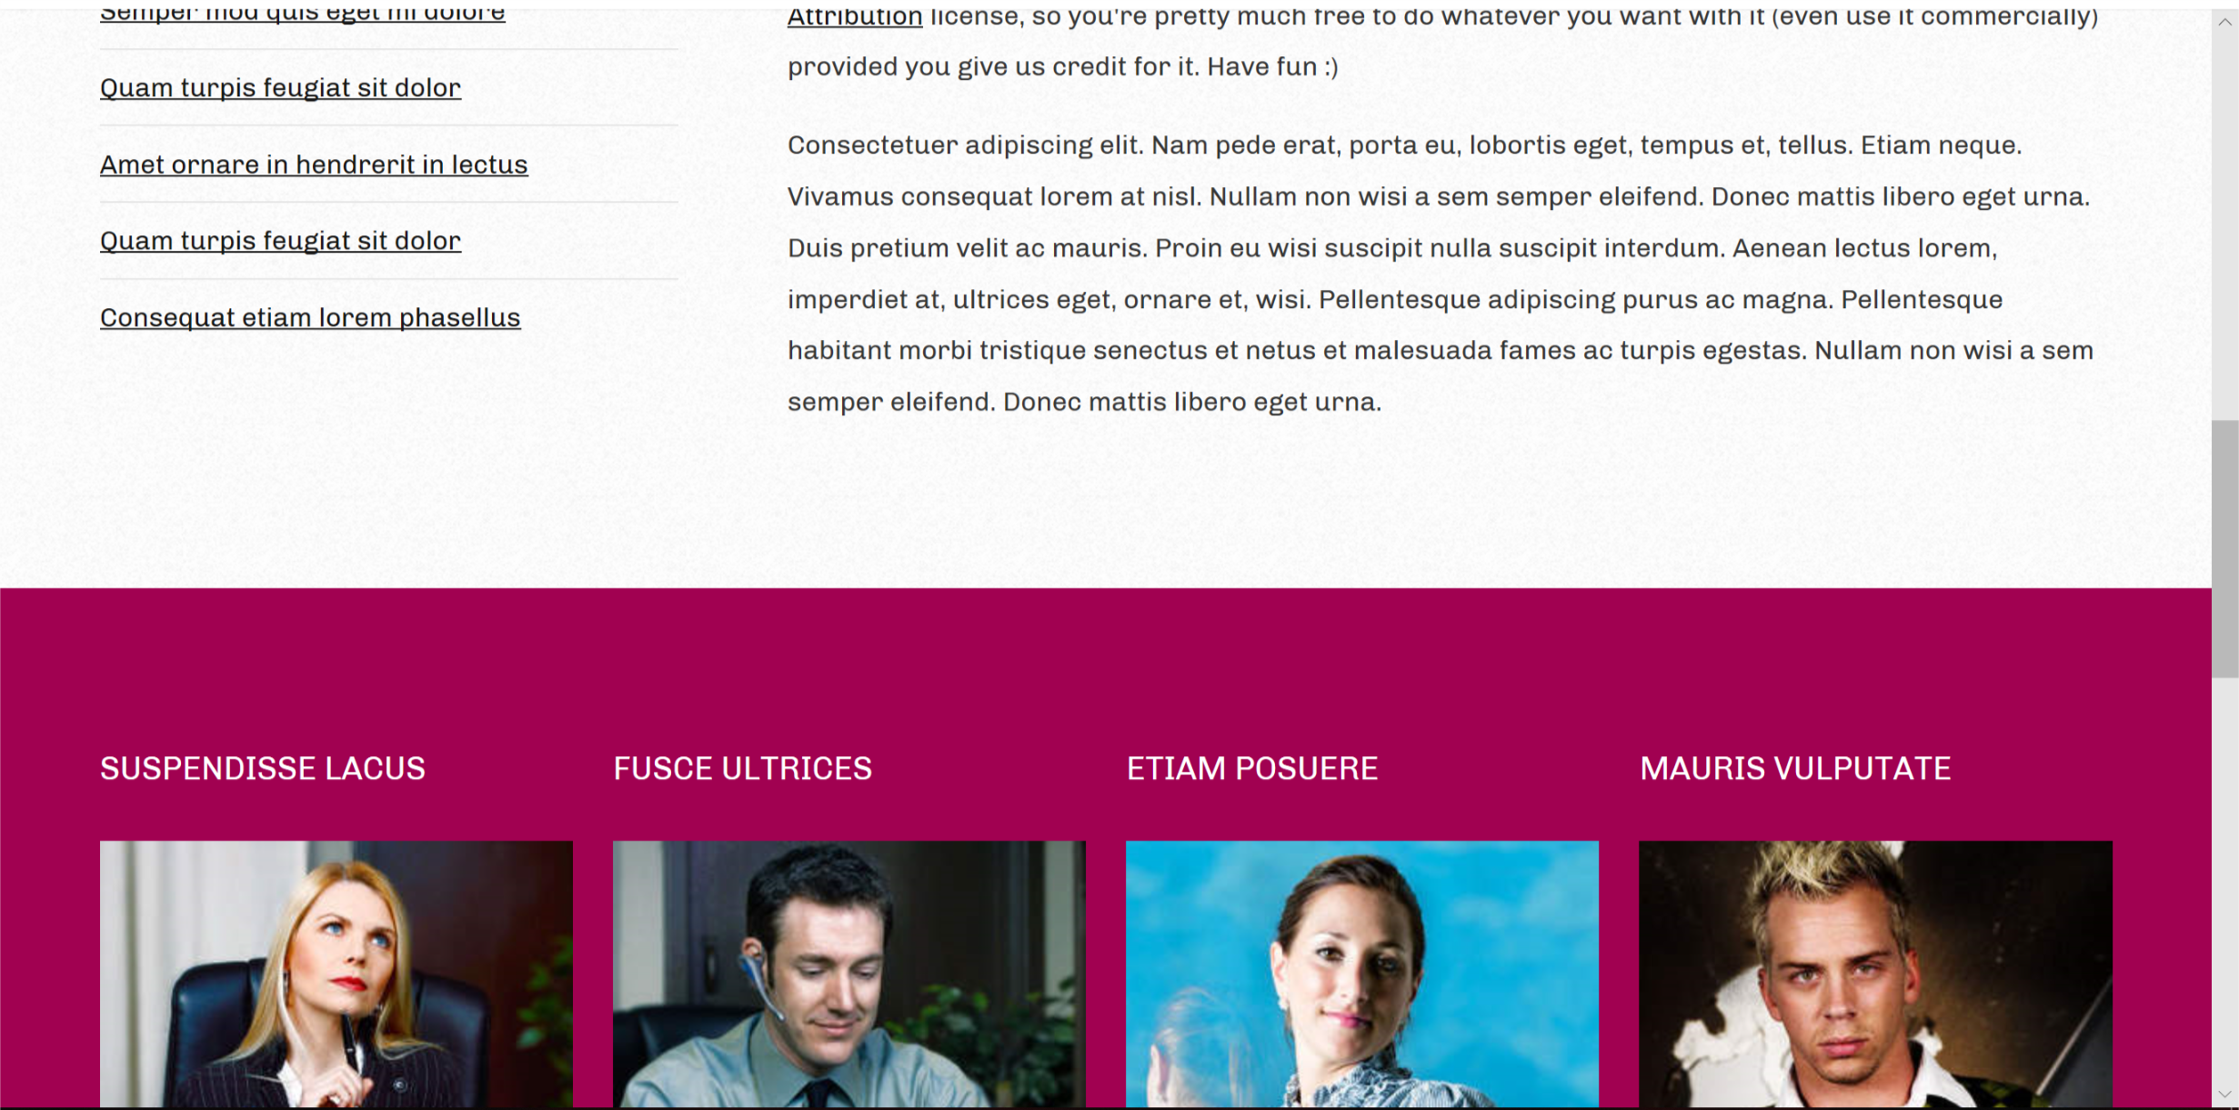

1 pt. **Color Combination** We will be using colors related to NIU: Red, Black, White, Gray.

8 pts. **Wireframe & Mockup**: Use Balsamiq to create a simple sketch of the layout for your site to communicate the idea.

